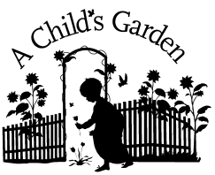
A Child’s Garden Two’s Class
Permission Slip

Please check off and sign the following based on your child’s needs:

__ I give permission for my child to sleep in a crib at nap time if needed.
__ I give permission for my child to sleep on a mat at nap time.
__I give permission for sunscreen to be applied. Product will be supplied by parent.
(If a 9-12 student, please apply at home.)
__I give permission for bug spray to be applied. Product will be supplied by parent.
(If a 9-12 student, please apply at home)
__I give permission for 1% milk to be served to my child.
__I prefer to supply another type of milk __________________ (list)
__ I give permission for diaper cream to be applied. Product will be supplied by parent.

Parent Signature: ______________________________
Date: _______________

